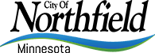
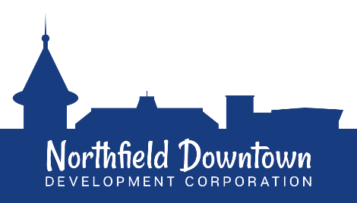
Visions of Northfield’s Future

The Northfield Downtown Development Corporation (NDDC) was selected in Fall 2018 to participate in the Artists on Main Street program (AOMS), a three-year community development initiative offered through Rethos: Places Reimagined and Springboard for the Arts, with support from the Bush Foundation. The program explores the intersection of arts and culture, downtown revitalization, and historic preservation by investing in “creative placemaking” projects within a defined area of a community. Creative placemaking has many different definitions, but could be simply described as using art and other creative activities to make positive physical, economic, and social impacts within a particular place or community.
The overarching goals of Northfield’s program include:
  - Providing art and creative placemaking experiences that draw people to shop, dine and connect in Downtown Northfield;
  - Enhancing the downtown’s aesthetics through the creativity of our local artists;
  - Utilizing the arts as a springboard for improving diversity and inclusiveness in Downtown Northfield across all cultures.
In this second year of Northfield’s program, we are looking to support creative placemaking projects under the theme: “Visions of Northfield’s Future.” Proposals might, for example, address concepts such as evolving demographics and increasing cultural diversity; climate change or the environment/ nature in general; the impact of technology and digital life on physical communities; or many others besides. We encourage all applicants to think broadly and make a case for your vision. Preference will be given to projects that embody a positive vision of the future, in accordance with the principles of creative placemaking – think of adjectives such as welcoming, delightful, whimsical, thought-provoking, and so on.

PROJECT PROPOSAL MATERIALS
Please send the following in pdf or word format to Greg Siems at greg@nddc.org with the subject line AOMS 2020 application

1. COVER PAGE (1 page max)
- Project name (something catchy!)
- Project Summary (keep it short – how would you describe to someone on the street? One or two paragraphs should be sufficient.)
- Lead Artist(s) Contact info
  - Name
  - Address
  - Phone
  - Email
  - Website
  - Describe yourself as an artist. This is not about credentials – what is it that you do as an artist? (3 sentences max.)
- Address/Location(s) of proposed project (describe if necessary)
2. PROJECT PROPOSAL (3 pages max)
- The Project (What are you going to do? What issues or community needs/opportunities will your project represent under the theme of “Visions of Northfield’s Future”? If it is related to existing work, how is it new or different? How will the Northfield community be involved in the project: as co-creators, participants, consumers, or any combination of those things?)
- The Plan and Timeline (Describe the activities and timeline required to complete your project by May 31st, 2021.)
- Community collaborators (Are you working with a business, nonprofit, school, or other group to make this project happen? If so, please describe the nature and extent of their involvement.)
- What is your current connection to the Northfield community (resident, former resident, student, alumni, etc.)? How does this connection shape your creative work in general, and how will it impact your proposed project?
- Outreach/Promotion (Who is your audience? How will you let people know about your activity or event?)
- Additional Info (Is there anything else you would like to tell us about your proposal?
- Please provide up to 5 images of “before” pictures of the site(s) where the project will happen. Nothing fancy here–cell phone photos are acceptable! Submit images as jpgs and provide descriptions if necessary at the end of this document.
- Optional Supporting Images/Work Samples (Include if you wish to submit draft designs, mock-ups or other relevant materials that reflect the final product for your Project.)

3. BUDGET (1 page max)
- Use the template below as a guideline for developing your budget.
Expense Item | Cost
Time (artist/collaborator compensation)

Materials (describe)

Other

Total

Income Sources | Amount
Artists on Main Street support (up to $10,000)
Other (not required - but please describe if you have secured or plan to apply for other funds)
SUBMISSION, DEADLINES AND REVIEW PROCESS
Proposals must be submitted by 12:00pm on Friday, July 17th. An independent Public Art Review Committee (PARC) comprised of local artists, arts enthusiasts, and program administrators will judge proposals based on the strength of the responses to the questions in section 2 of this application. Applicants will be notified of the PARC’s decisions by Monday, August 3rd.

NEXT STEPS, IF YOUR PROJECT IS ACCEPTED:
- Sign contract and receive 80% of project support (i.e. $800 if you’re requesting $1000).
- Initiate and complete project by May 31st, 2021, including a final report (this will be a simple set of questions asking what you did and an updated list of expenses. The form will be sent with your contract when the project is confirmed).
- Participate in a mid-project check-in with program leaders in early January 2021 to share your progress and address any challenges that have arisen.
- Help NDDC, ACC, and Guild communicate information about your project while you create and implement it, by providing photos and/or brief statements when requested. The goal is to get the community excited about your project!
- In any description or credits of project, always use the following language: “This activity is part of Artists on Main Street, a partnership organized locally by the NDDC, Northfield Arts and Culture Commission, and Northfield Arts Guild, with support from Rethos: Places Reimagined, Springboard for the Arts, and the Bush Foundation.
- Schedule and plan a public event (for example a dedication ceremony if the project is a physical piece) to commemorate your project. Please send the NDDC, ACC, and/or Guild your preferred date for this event as you as you know. We are also happy to help you think through options, possibilities, and dates for this element.
- Receive remaining balance of support and celebrate with your friends and partners!

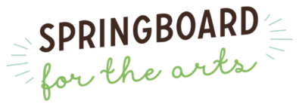
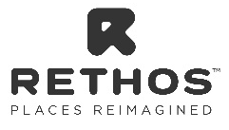
HAVE FUN AND GOOD LUCK!

